Where to live: Toronto or NYC

1. Intro

New York, Toronto, or ...where does the data tell me to move to? These two cities are economic hubs and are very diverse. When comparing both cities, which one stands out? This is important for someone who might have job offers in both cities. It would great to compare quality of life factors such as housing costs, crime rates, restaurant and entertainment venues, and essential locations such as, hospitals or grocery stores. Which neighbor hoods in each city are the best for these considerations? This project will aim to provide insight about quality of life (housing, crime, venues) in each city and then amongst them. In doing so, one will be able to make a more informed decision about where to live in each city, and if to choose amongst them, which city to move to.

1. Data

To compare the 2 cities, I need to use geographic data from each city that include neighborhoods names, crime data, housing data, and venues data. The venue data is collected from Foursquare.

Geographic data sources:

* New York City (JSON): <https://cocl.us/new_york_dataset>
* Toronto: <https://en.wikipedia.org/w/index.php?title=List_of_postal_codes_of_Canada:_M&oldid=945633050>

Housing Data Sources:

* New York City: <http://www.city-data.com/zipmaps/New-York-New-York.html>
* Toronto: <https://www.kaggle.com/mnabaee/ontarioproperties>

Crime Data sources:

* New York City: <https://data.cityofnewyork.us/Public-Safety/NYC-crime/qb7u-rbmr>
* New York City GeoJSON: <https://raw.githubusercontent.com/dwillis/nyc-maps/master/police_precincts.geojson>
* Toronto: <https://data.torontopolice.on.ca/>
* Toronto GeoJSON: <https://raw.githubusercontent.com/jasonicarter/toronto-geojson/master/toronto_crs84.geojson>

1. Data Cleaning

I will make sure to doing a filtering of the data to ensure that none existent values are omitted, and that data like housing and crime are comparable between cities. I will be comparing the most recent complete year of data.

1. Methods

* Maps
  + Neighborhood Geographic Maps
  + Crime eat Maps
* K Clustering
  + Housing
  + Venue Data
* Overlap clusters and maps

Results

* + Neighborhood Geographic Maps
  + 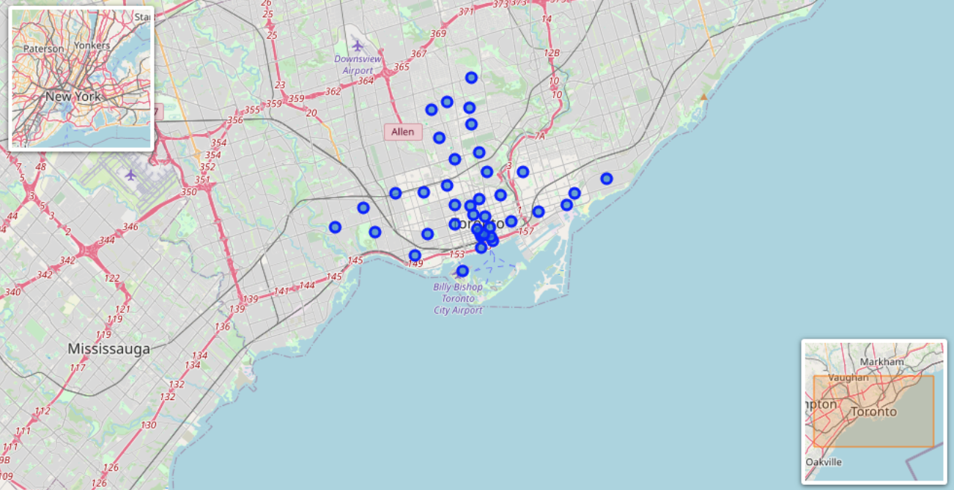Toronto: 39 different hoods.
  + 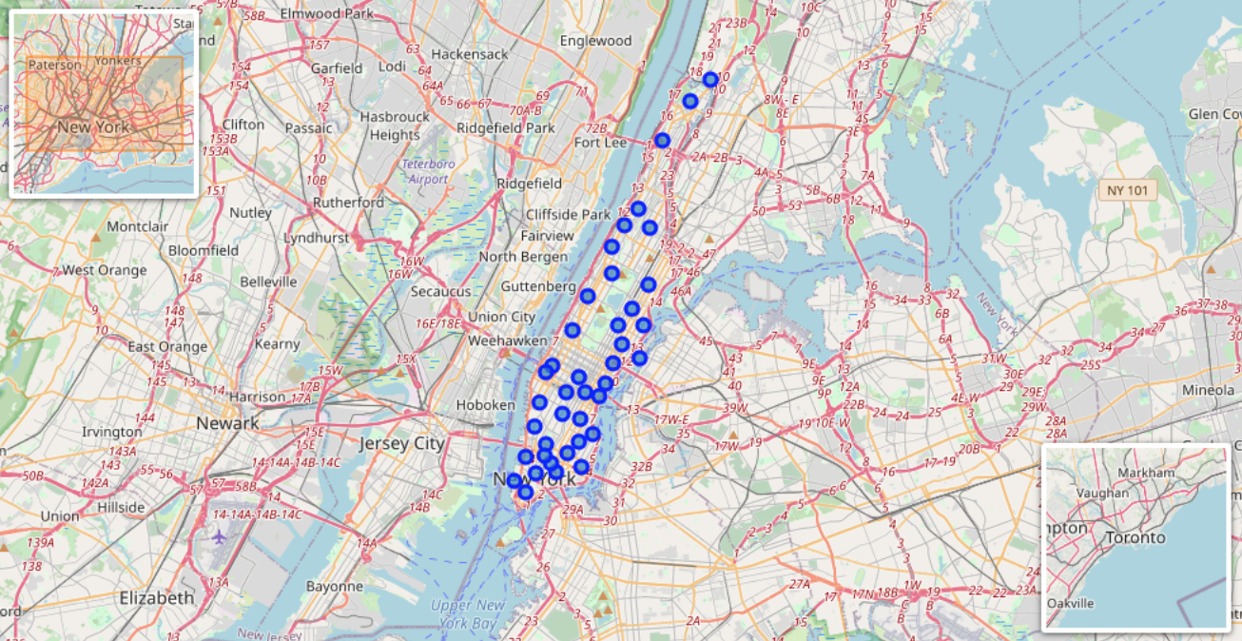NYC: 40 different hoods.
* Crime Heat Maps
  + 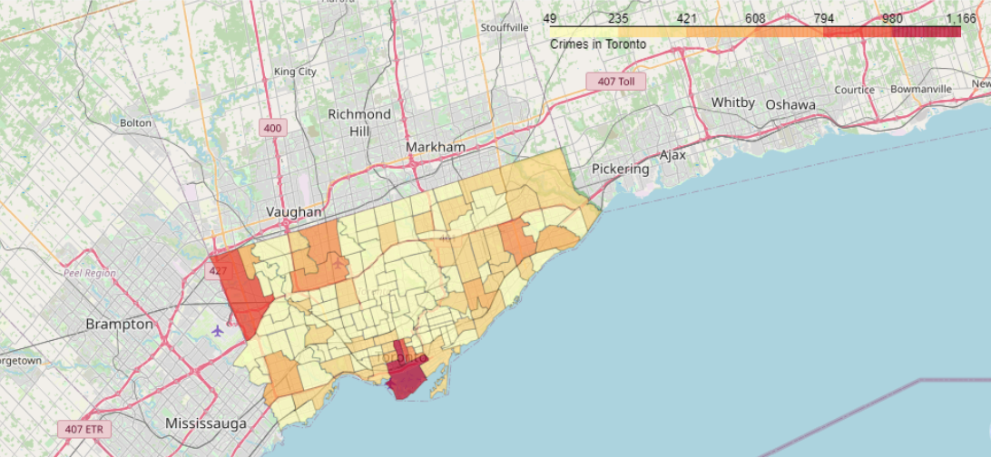Toronto Crime: only one hood has a much higher amount of Crime than the rest of the city.
  + 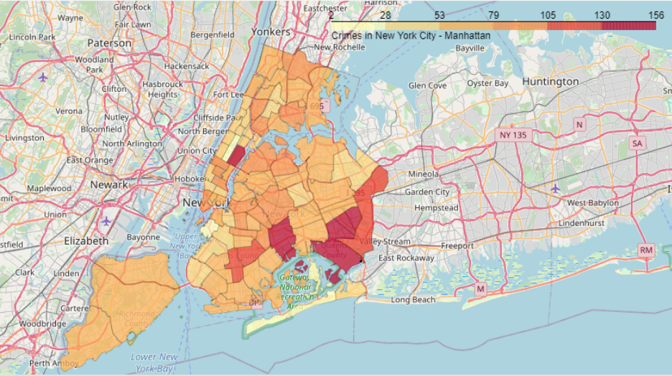NYC Crime: Over 5 hoods have a much higher level of crime than the rest of the city.
* Housing (Color Cost, Red = high, Orange = Mod, Green = Low
  + 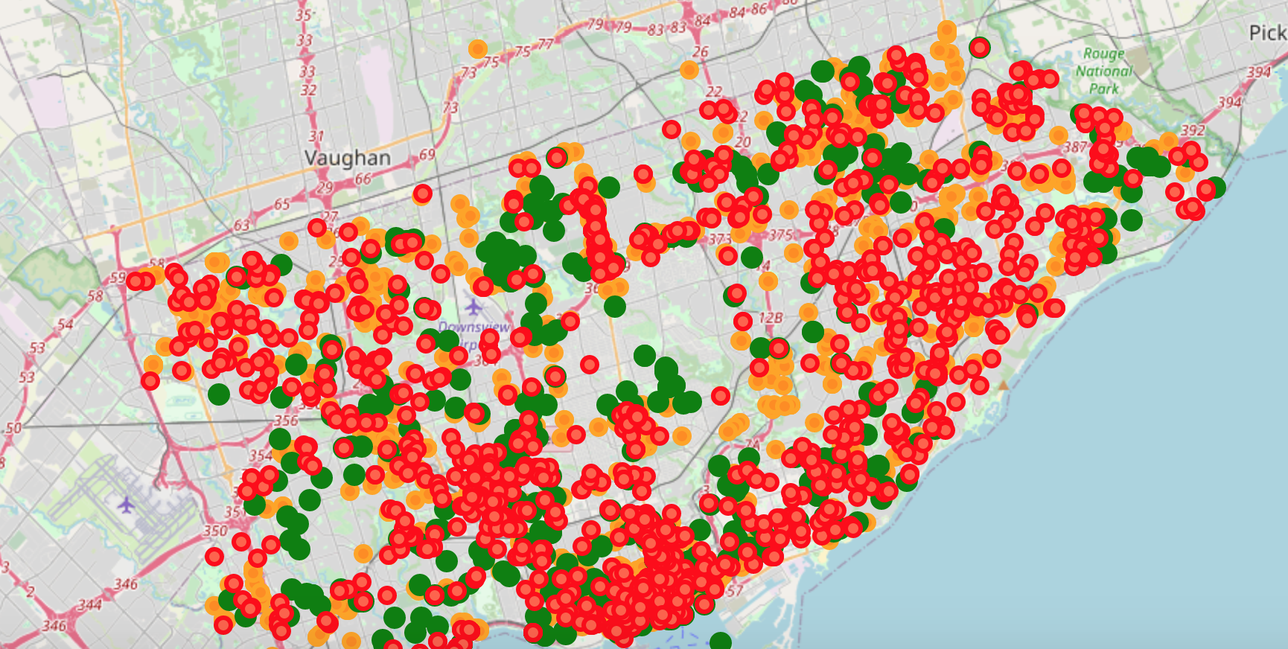TO HOUSING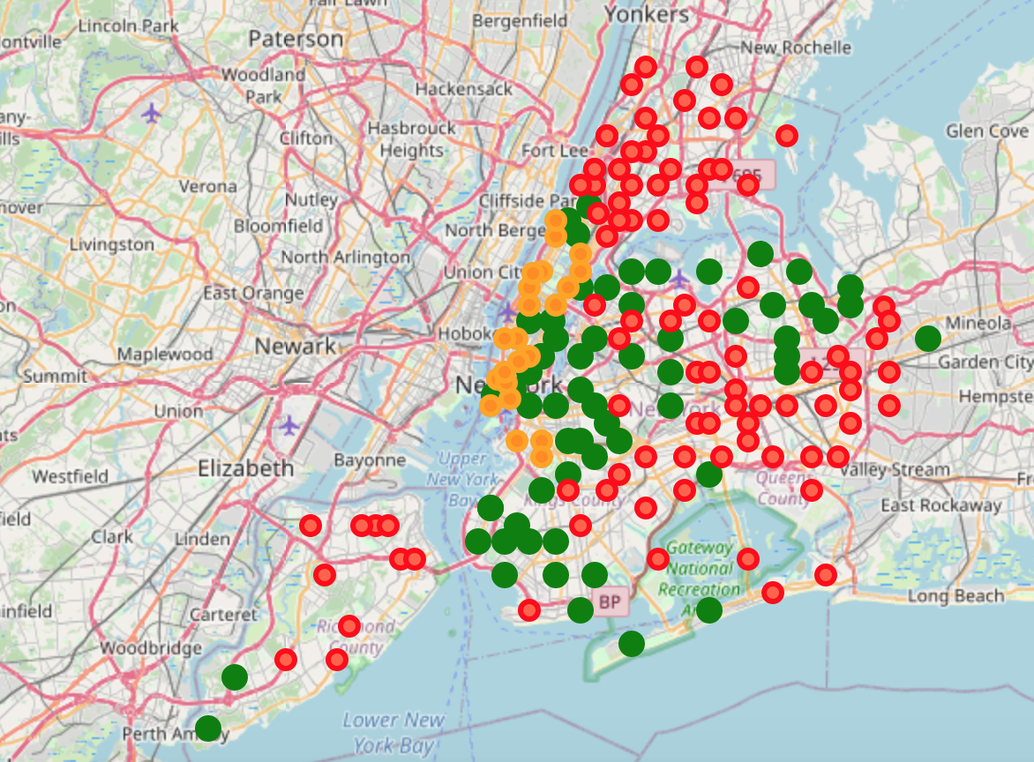NYC HOUSING
* VENUE DATA(Color Code, Red = Indoor Entertainment, Blue = Outdoor Spaces)
  + 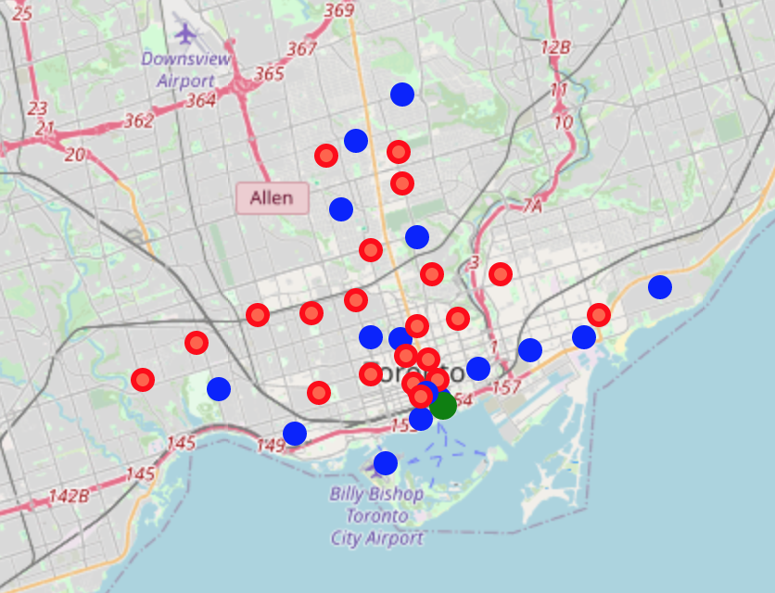TO Venues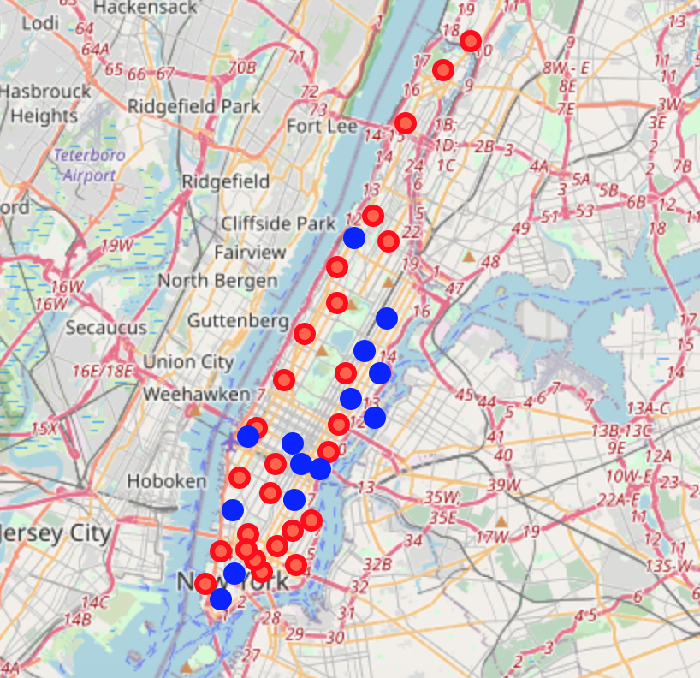NYC Venues
* OVERLAPPING Crime, Housing, MAPS
  + 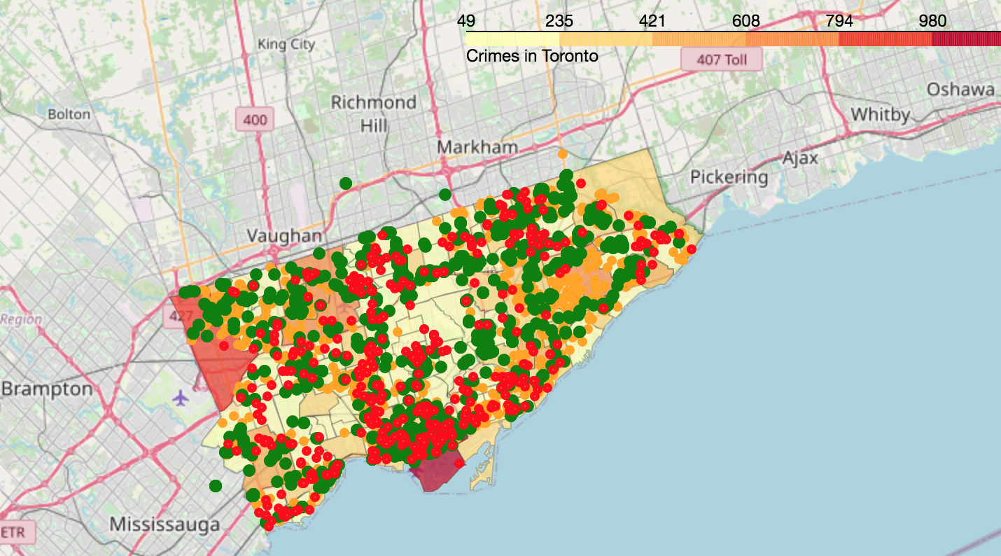TO Livablity Maps
  + 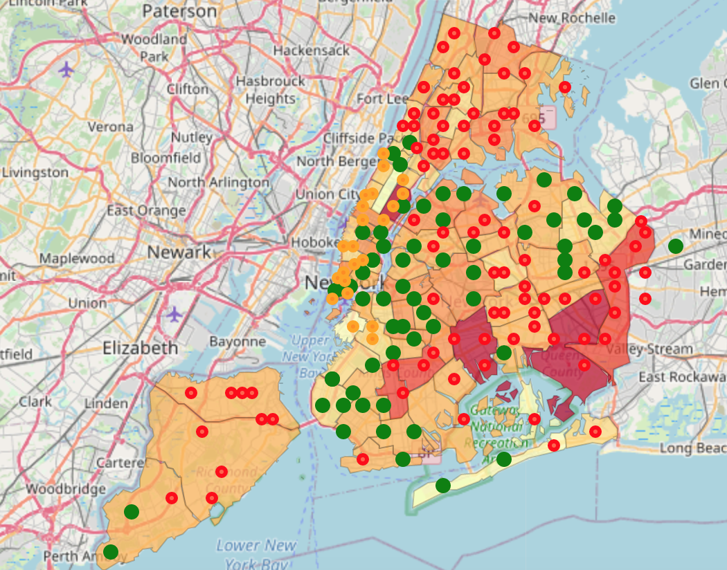NYC Livablity Maps

Conclusions

Based on the observations from the data, while both are pretty livable, Toronto has a larger amount of hoods with less crime and lower housing cost. They are pretty much tied from a venue point of view, but NYC seems to be much more expensive and have more crime. If I had a job offer, I would make my way to the 6 to hang out with Drake.